Chapter 10

Job Design and Work Measurement

**Background**

More than any other, this chapter emphasizes the *management* part of the operations manager’s job. Most students will have held at least a part-time job, so they should be able to relate to much of the content. Were their jobs appropriately designed and compensated? If desired, lots of time can be spent discussing psychological and reward issues for employees. The methods analysis section ties in well with Chapter 7 on process strategy. Upon reaching the labor standards section of the chapter, instructors could devote some class time to bringing students up front and actually demonstrating a time-and-motion study for a particular task. In fact, instructors could introduce delays or other confounding circumstances such as using a task that pulls an item off of a high shelf—a six-foot student might be able to reach it directly while a 5-foot student might have to go find a chair first. Such an example introduces issues of designing tasks that workers can physically handle and also the dangers of basing time studies on just one subject.

**Class Discussion Ideas**

1. Have the students identify job-related characteristics or rewards that they personally would find motivational. This can work particularly well with groups of senior students or MBAs who are currently on the job market. Instructors might even ask if anyone has had a job with rewards that he or she did *not* feel was particularly “rewarding” or motivational.

2. Ask the students to identify examples of visual workplace principles in operation at local businesses or organizations. They should describe the system and explain how this improves the operation.

3. Ask the students if any of them have ever held particularly boring jobs, and then try to determine how, acting as managers, the respective firms might have implemented job expansion tactics to help retain employees holding such positions.

4. Ask the students if any of them have ever managed unhappy workers. Was there anything that they tried that successfully turned those workers around?

**Active Classroom Learning Exercises**

1. Many visual and motion exercises can be used to introduce ergonomics and the man-machine interface; here is one. A machine design requires that students operate a foot pedal on the machine that requires that they lift their right foot off the floor and make clockwise circles with it. Now, while doing this, they must draw the number ‘6’ in the air with their right hand. Their foot will most likely change direction. (Man is a tool-using animal, but the tools must be designed so man can use them.) It may help verify the results to have the class pair up and have one person try the activity while the other observes. They can then try again with the roles switched.

2. Have the class split into groups. Using a different job or operation for each group (with which the group is familiar), have the students prepare a flowchart of the job. Using the flowchart, ask them to identify areas where process improvements might be possible. Groups can report their findings to the class.

3. Students often have trouble with the concept of where a performance rating (PR) comes from in time studies. The instructor can hand out a bunch of decks of cards and have students time their partners dealing a very neat bridge hand, i.e., 13 cards per player in four even piles. The students repeat the task twice more, and an average time per student is computed. It turns out that for this manual task, and many others, the Standard Time is known: 30 seconds. Then we can work backwards to find the PR when given the average cycle time and the standard time. This exercise can break the class up, and students may have fun seeing who has the highest PR for manual tasks.

**Company Videos**

1. *Hard Rock’s Human Resource Strategy (7:01)*

Why does Hard Rock Café have such a long waiting list of people who want to work for the company? Why is the turnover rate half that of the industry norm? Some of the reasons include great benefits, working in a rock and roll environment, good standards for training, good opportunities for internal promotions, the chance to express individuality (tattoos and body piercing are OK!), and the gift of a Rolex watch after 10 years of service. Part of Hard Rock’s mission is to offer the Hard Rock family a fun, healthy, and nurturing work environment to ensure the company’s long-term success. “Rock 101,” the entry-level management course, provides not only professional development training, but personal development as well, all in a rock and roll environment. Every employee receives training, which is supplemented by a series of instructional CDs. Much of the firm’s success seems to be due to hiring practices. Managers take time to hire the *best qualified*, as opposed to grabbing the best available at the moment. The attractiveness of the job allows such a practice to thrive.

Prior to showing the video, instructors might ask any students who have worked in restaurants to share information about some of the employee benefits, work rules, and working environment. After showing the video, discussion might center around what Hard Rock offers employees that seems to exceed the norm for most other restaurants. In addition, what do students think about the allowance (and sometimes encouragement) of “rocker” appearances of employees where tattoos and piercing may be omnipresent? Disneyworld allows none of that—forcing employees to sport the clean-cut “Disney look.” Do both strategies make sense for these two separate service firms? Is either strategy unfair or offensive to employees or customers? Finally, employees are hired at Hard Rock to create an authentic and memorable experience for customers. Succeeding in this endeavor requires a constant infusion of energy and enthusiasm from the workers. How can such work attitudes be determined in the interview process? And how can they be maintained after months and months of doing the same job?

**Cinematic Ticklers**

1. *9 to 5 (Lily Tomlin, Dabney Coleman, Dolly Parton, and Jane Fonda), 20th Century Fox, 1980*

The boss (Dabney Coleman) is a control freak who attempts sexual harassment with his secretary (Dolly Parton) and who also is generally unsupportive of his subordinates. After three employees kidnap him, they begin to implement job design changes in his name that greatly improve motivation and productivity. Selected clips could focus on some of the boss’s sleazy tactics and the description of the specific job design changes that the women implemented.

2. *Office Space (Ron Livingston and Jennifer Aniston), 20th Century Fox, 1999*

Among the funniest scenes in the movie are passive-aggressive attempts by the boss to get his employees to complete their work or even come in over the weekend to work overtime.

3. *Modern Times*, *(Charlie Chaplin), CBS/FOX VIDEO, 1992 (1936)*

If not already shown with Chapters 1 or 7, this assembly line clip goes well with the Chapter 10 discussion of labor specialization.

**Presentation Slides**

INTRODUCTION (10-1 through 10-9)

Slides 7-9: This Global Company Profile provides a nice example of teamwork, training, continuous improvement, and work measurement. More than most jobs in existence, the NASCAR pit crew member must make every split second count. Only if every team member meets or exceeds standards will the driver likely have a chance to win the race. Such precision involves not only up-front training, but also continuous practice and exercise. And good teams evaluate themselves, sometimes during the actual race itself, to focus on continuous improvement. The surprisingly large salaries for pit crew members attest to the difficulty and seriousness of these jobs.



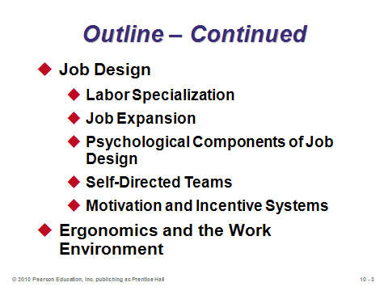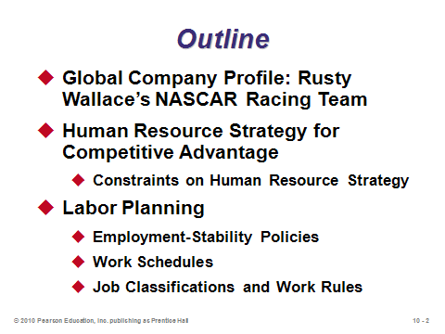

**10-1 10-2 10-3**

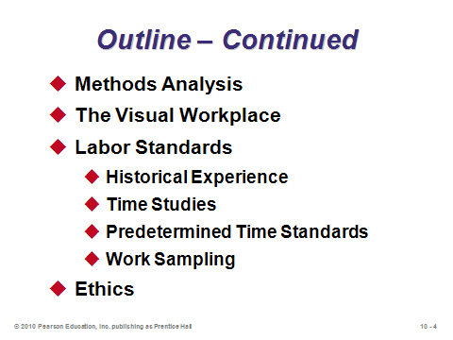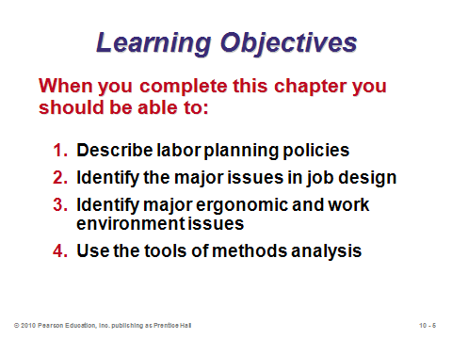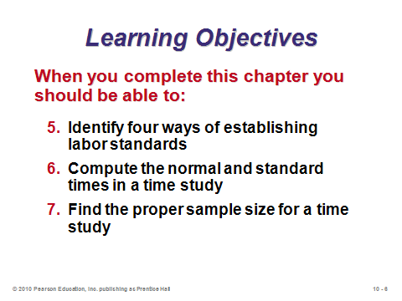

**10-4 10-5 10-6**

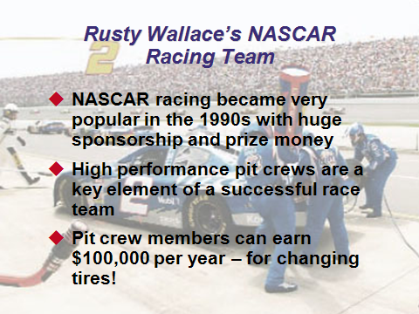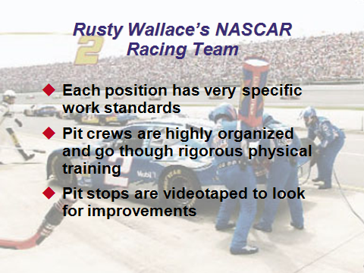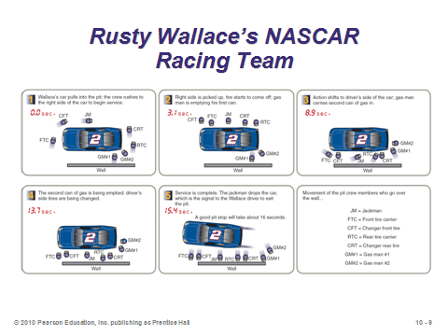

**10-7 10-8 10-9**

HUMAN RESOURCE STRATEGY FOR COMPETITIVE ADVANTAGE (10-10 through 10-12)

Slides 10-12: We often say that operations management deals with the management of *processes*, while organization (or human resources) management deals with the management of *people*. However, the two fields must merge at some point to run a successful business. Operations managers without good people skills may not be operations managers much longer. The success of most businesses, even highly automated ones, ultimately depends upon the effectiveness of people—line workers and managers. Slide 11 reminds us that part of the human resource task is to generate effective utilization of people, but just as important can be creating a workplace that produces job satisfaction, employee comfort, and hopefully some level of fun as well. Slide 12 (Figure 10.1) suggests that many decisions made about people are constrained by other operations decisions. Technology and process decisions, in particular, may shape the workplace environment and place significant constraints on workers.

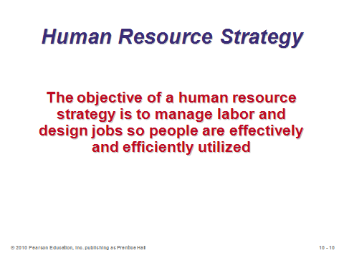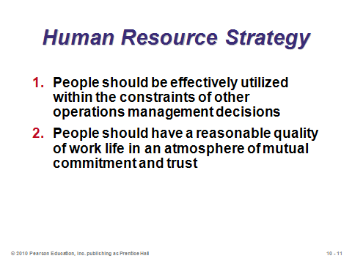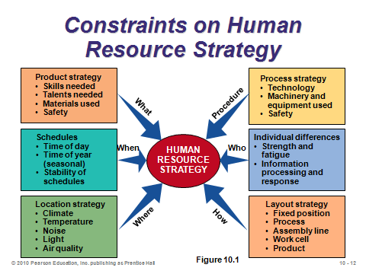

**10-10 10-11 10-12**

LABOR PLANNING (10-13 through 10-16)

Slides 13-14: Employment stability deals with the number of employees maintained by an organization at any given time. These two slides describe the two very basic (and opposite) employment stability policies. Looking ahead to Chapter 13, these align perfectly with the pure policies generated from aggregate planning: *chase policy* (follow demand exactly) vs. *level policy* (hold employment constant). Companies can decide whether they want the cost-minimizing policy emanating from the aggregate plan to drive the employment stability policy, or whether they want to hold to an employment stability policy that would then dictate the aggregate plan.

Slide 15: This slide identifies the major work schedule variations. The standard workweek in the United States remains at 40 total hours (much higher for management employees of some companies—students should be prepared!). Some European countries such as France and Germany have reduced that standard number by a few hours. Flextime and flexible work weeks have become very popular recently, and communications technology has facilitated these changes. While sometimes creating a scheduling headache for operations managers, the availability of flexible work schedules can help to attract and retain excellent employees. Some workers really appreciate the opportunity, for example, to have Fridays off to run errands while other businesses are open around town. Finally, many firms employ a large number of part-time workers. In some cases, such schedules fit perfectly for an individual’s desired work-life balance. However, many such jobs offer no fringe benefits such as health insurance (which saves money for the companies but can produce a serious financial burden on the workers). As those costs continue to skyrocket, companies are being pressured by the media and the public to provide benefits to part-time help.

Slide 16: Many organizations, particularly union shops, have strict job classifications. We’ve all heard stories about, for example, managers not being allowed to change a light bulb in their own offices because that task is someone else’s specific responsibility. Unions often strive for such specific classifications in order to protect jobs for their members. For management, however, this lack of flexibility can produce burdens. Building morale and meeting staffing requirements that result in an efficient, responsive operation are easier if managers have fewer job classifications and work-rule constraints. Japanese factories, for example, are known to have far fewer job classifications than their American counterparts.

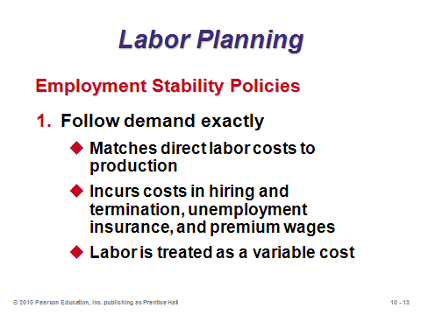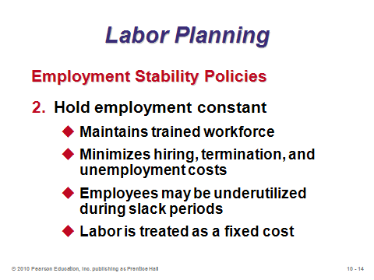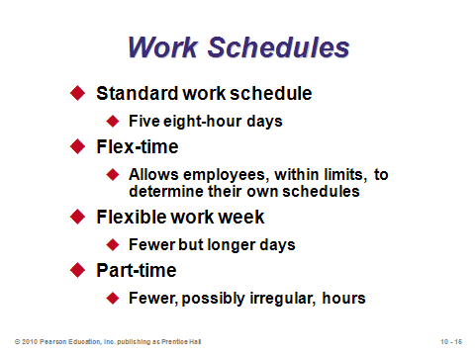

**10-13 10-14 10-15**

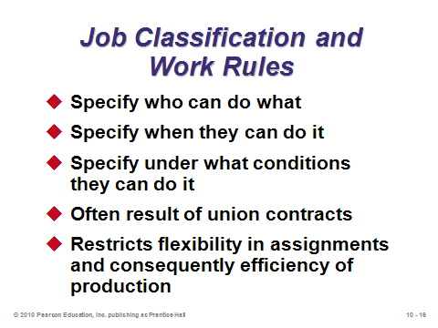

**10-16**

JOB DESIGN (10-17 through 10-30)

Slide 17: This slide identifies five components of job design that are studied in this section.

Slide 18: The classic assembly line represents the case where labor specialization may enhance productivity the most. Instead of having the workers build an entire product individually, each worker focuses on a subset of tasks that is repeated for every product coming down the line. This slide identifies the classic advantages of labor specialization, and the concept of learning curves (Module E) applies here. The benefits should be weighed against the downsides of having mind-numbing jobs and the failure of such jobs to be able to bring to the workplace the employee’s full set of skills (both manual and intellectual).

Slides 19-20: Job expansion, adding more variety to jobs, helps to improve the quality of work life for many employees. Slide 19 identifies four of the major approaches to job expansion: (1) *job enlargement*—adds tasks requiring similar skills, (2) *job rotation*—moves the employee from one specialized job to another, (3) *job enrichment*—adds planning and control (the mind) to the job, and (4) *employee empowerment*—assigns responsibility to employees for decisions normally associated with staff specialists. Recall that employee empowerment is considered to be an important concept in Total Quality Management (Chapter 6). Slide 20 (Figure 10.2) provides an example of job expansion via job enlargement (horizontal expansion) and job enrichment (vertical expansion).

Slides 21-23: These slides cover the psychological components of job design. Slide 22 describes the famous Hawthorne studies (conducted in the late 1920s at a Western Electric plant), which introduced the idea of psychology in the workplace. Researchers have since conducted numerous studies regarding the psychological components of job design. Slide 23 summarizes much of that work into five desirable characteristics of job design.

Slide 24-26: Slide 24 (Figure 10.3) suggests a job design continuum showing the four techniques of Slide 19, culminating in *self-directed teams*, defined as a group of empowered individuals working together to reach a common goal. Slide 25 describes why such teams can be so effective. Slide 26 provides additional information not found in the text about how such teams should be managed.

Slides 27-29: Slides 27 and 28 present advantages and limitations, respectively, of job expansion. Slide 29 suggests how the dramatic difference in training in Sweden and Japan compared to the U.S. is directly linked to the emphasis in those countries on job expansion.

Slide 30: Properly designed incentives systems can be powerful motivators for employees. Such schemes may be based on individual performance, team performance, or even organizational performance. Sometimes, bonuses or raises come after an employee has attained certain knowledge through perhaps completing a training program or an academic degree. One caveat about bonuses—presenting a bonus one year may create similar expectations in future years. If the conditions for receiving the bonus change, incentives may backfire because employees may not be receiving money that they now consider to be part of their overall compensation package. Once introduced, bonus systems may be difficult to take away without generating employee backlash. Instructors can insert a short class discussion at this point to explore good incentives for a professional basketball or football player. Would bonuses based only on individual statistics make sense? Interested instructors could also present various CEO incentive schemes and ask the class if these are designed to drive the best decisions for the organization.

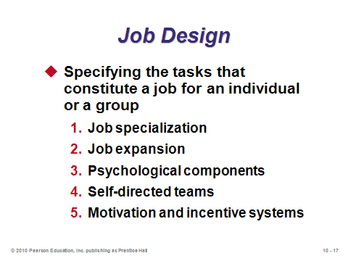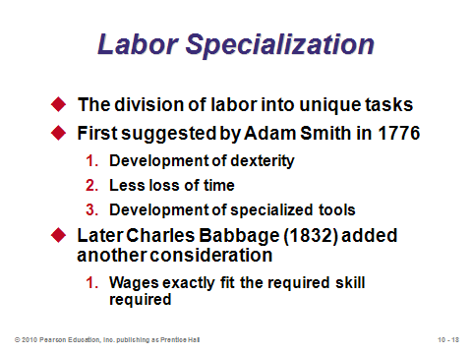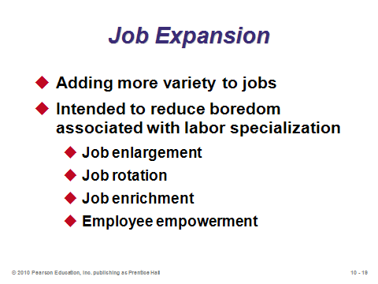

**10-17 10-18 10-19**

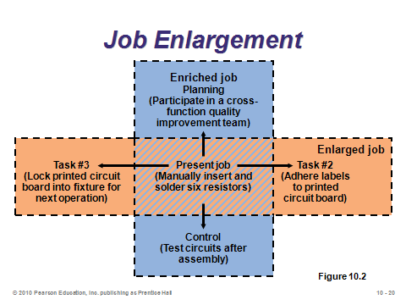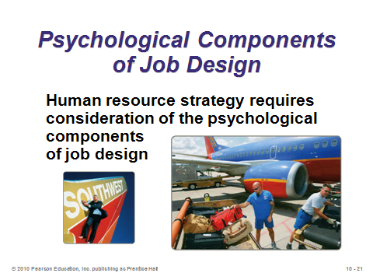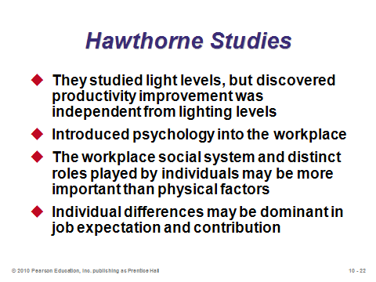

**10-20 10-21 10-22**

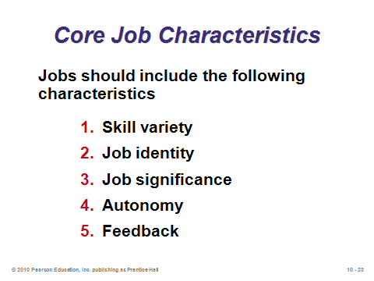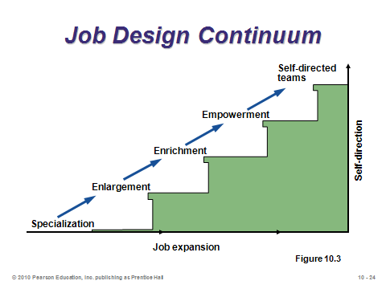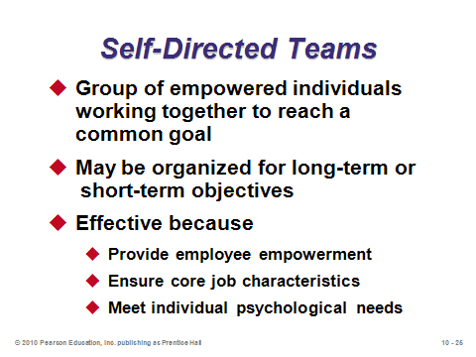

**10-23 10-24 10-25**

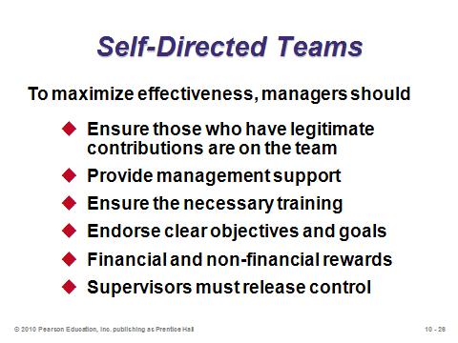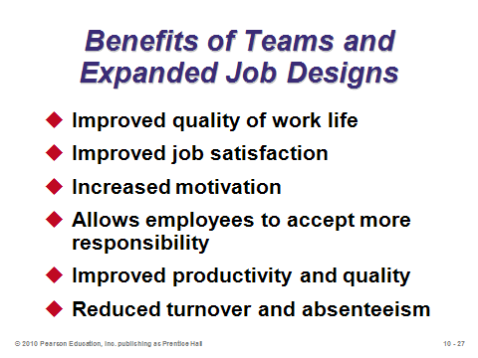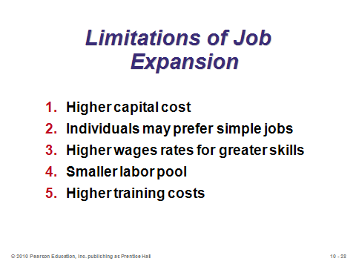

**10-26 10-27 10-28**

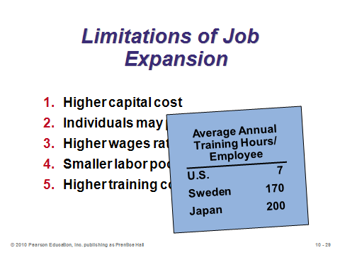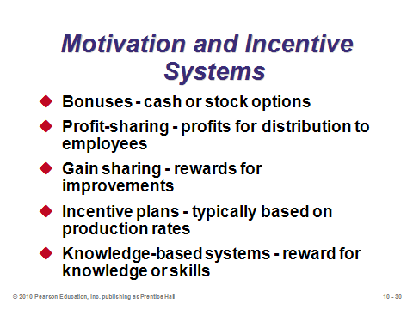

**10-29 10-30**

ERGONOMICS AND THE WORK ENVIRONMENT (10-31 through 10-35)

Slides 31-32: These slides identify some of the important issues in creating a proper work environment. Tools, furniture, keyboards, etc. should be designed with employee comfort and productivity in mind. How the machines provide feedback to operators through sight, sound, and feel is important as well. Also, aspects that affect the senses, such as illumination, noise, temperature, and humidity should be carefully controlled.

Slides 33-35: These slides provide information about light and sound under various conditions. The Occupational Safety and Health Administration (OSHA) has established certain regulations for employee protection under various environmental conditions.

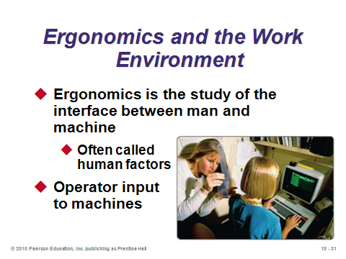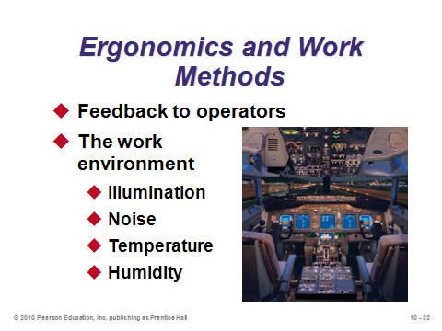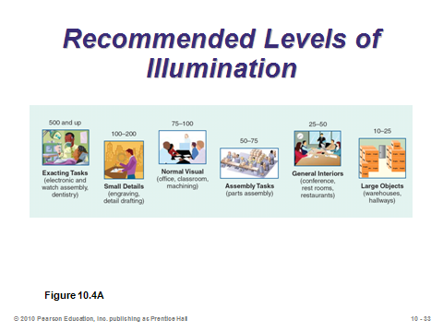

**10-31 10-32 10-33**

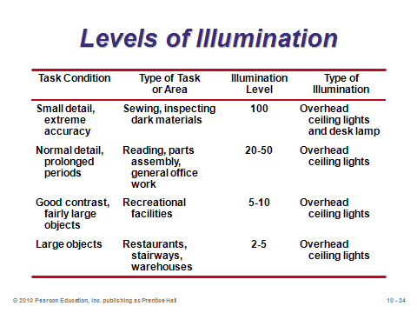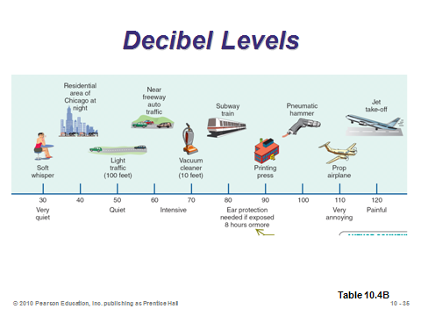

**10-34 10-35**

METHODS ANALYSIS (10-36 through 10-41)

Slides 36-41: Slide 36 describes three uses for methods techniques, and examples of four of these techniques are provided in the following five slides. Slides 37 and 38 (Figures 10.5(a) and (b)) provide a *flowchart* for an old method and new method, respectively. The new method has improved work flow and requires less storage and space. Slide 39 (Figure 10.5(c)) illustrates a *process chart* for the method shown in 10-38. Every sequential step in the process should be identified, including all operations, transportation, inspection, delay, and storage. For transportation steps, a column records the distance, while a second column records the time for the other types of steps. Slide 40 (Figure 10.6) provides an example of an *activity chart* (also called a *man-machine chart* or a *crew chart*) depicting a two-person oil change operation. Such a chart helps to understand crew or man-machine interaction. Slide 41 (Figure 10.7) provides an example of an *operations chart* (also called a right*-hand/left-hand chart*) for a bolt-washer assembly. The chart uses the same symbols as a process chart, but splits activities into right-hand and left-hand movements, which can help to point out wasted motion or idle time.

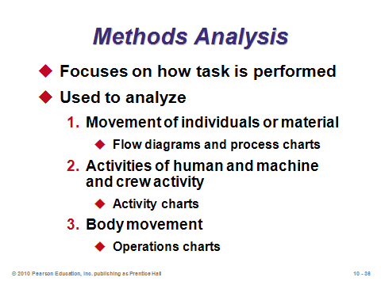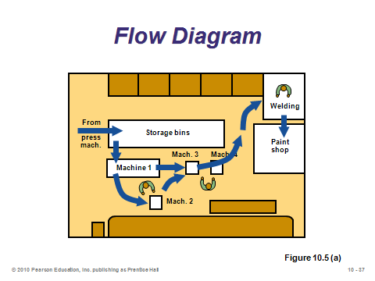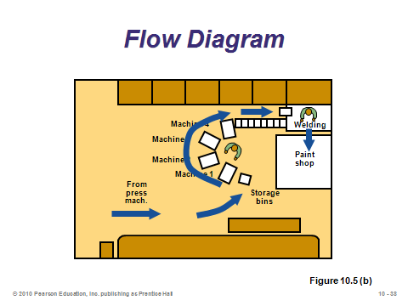

**10-36 10-37 10-38**

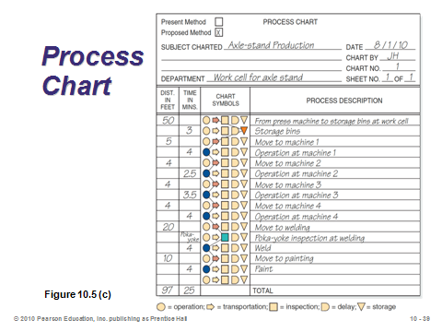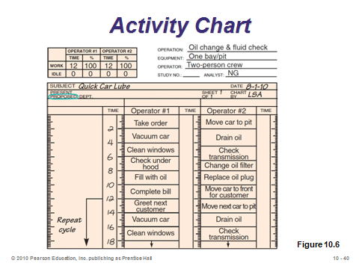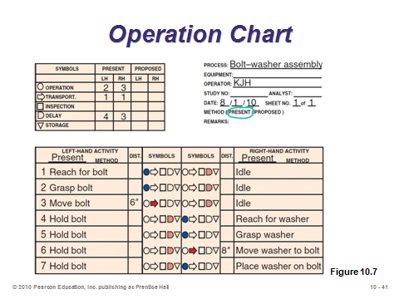

**10-39 10-40 10-41**

THE VISUAL WORKPLACE (10-42 through 10-46)

Slides 42-43: The idea of the visual workplace is to replace difficult-to-understand printouts and paperwork with simple visual displays of key information. Updates can occur quickly, providing timely information in an ever-changing environment. The visual workplace can eliminate non-value-added activities by making standards, problems, and abnormalities visual.

Slides 44-46: These slides from Figure 10.8 in the text display some very different implementations of the visual workplace.

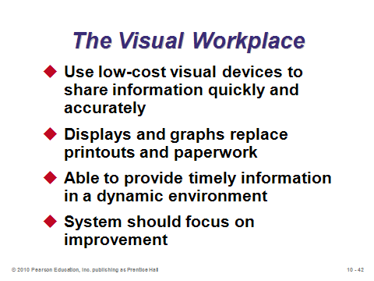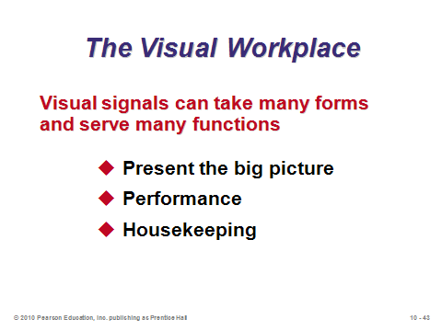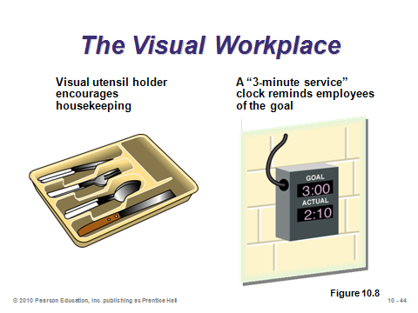

**10-42 10-43 10-44**

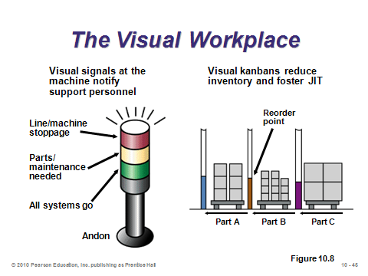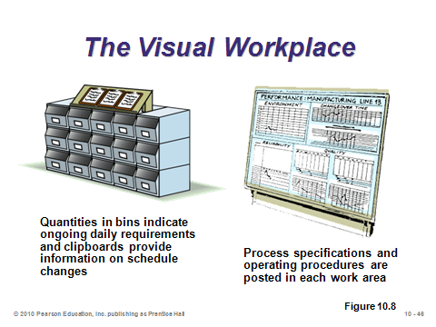

**10-45 10-46**

LABOR STANDARDS (10-47 through 10-82)

Introductory Subsection (10-47 through 10-50)

Slides 47-48: These slides introduce the concept of *labor standards*, representing the third requirement of an effective human resource strategy (after labor planning and job design).

Slide 49: This slide identifies seven uses for meaningful labor standards. Note how together these serve a variety of important functions, including determining the production cost of products, determining resource requirements, planning production and balancing assembly lines, devising proper compensation and incentive plans, and having a means to evaluate employee performance.

Slide 50: This slide identifies the four ways to establish labor standards, which are described in detail in succeeding sections.

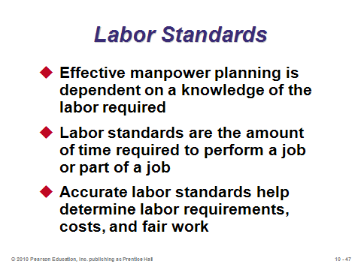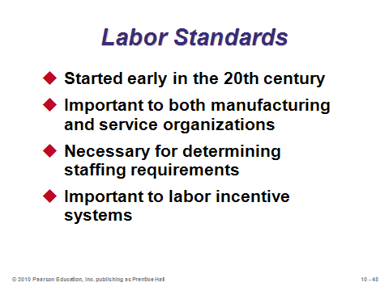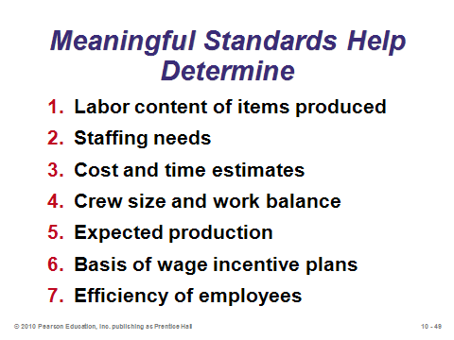

**10-47 10-48 10-49**

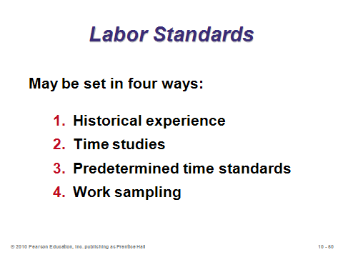

**10-50**

Historical Experience (10-51)

Slide 51: Historical experience represents the least preferred of the four methods of establishing labor standards. This method is unattractive because management cannot necessarily determine whether or not the old data represent a good work pace or a poor work pace, or whether they were recorded during any kind of unusual circumstances.

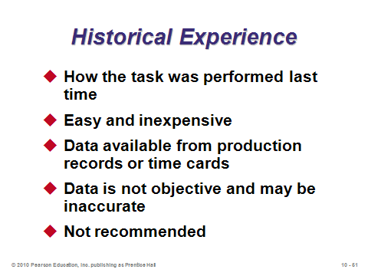

**10-51**

Time Studies (10-52 through 10-70)

Slide 52: Time studies (or *stopwatch studies*) date back to Frederick Taylor in 1881, and probably represent his most important contribution. The basic idea is to observe and time a worker performing a task and then use that time as the standard for all other workers under normal operating conditions. (Conditions for the sample should be carefully designed so that the subject does not produce an abnormal result. For example, if the worker believed that he or she was being judged in some way based on the test, then the worker might operate faster than normal. Alternatively, if the worker believed that his or her future compensation would be based on performance against the standard, then he or she might intentionally work slowly during the test.)

Slides 53-56: These slides present the eight steps to conducting a time study. Note that complete jobs (or tasks) are divided into specific *elements* that are timed separately. These elements often take no more than a few seconds. Note also the *performance rating factor* in Step 6. The factor attempts to adjust the average observed time to what a trained worker could expect to accomplish working at a normal pace. A value greater than 1 implies that the observed worker has performed faster than average, while a value less than 1 implies a slower than average performance. The Society for the Advancement of Management has established benchmarks for work pace, but the precise estimation of this factor remains something of an art. If there is no reason to believe that the observations are unusual, a performance rating factor of 1.00 should be used. Finally, the culminating standard time calculation in Step 8 includes an *allowance factor* (Slide 56), which adjusts time to complete a task to account for items like *personal time allowances* (usually 4% to 7% of total time) for rest room breaks, etc., *delay allowances* for known delays in the system, and *fatigue allowances* to account for human energy expenditure under various conditions.

Slides 57-60: These slides reproduce Table 10.1 from the text, which presents a sample set of personal and fatigue allowances in percentage terms for various classes of work. This suggests that the total allowance factor can add up to be a significant amount for certain physically or mentally demanding jobs.

Slide 61: This slide presents Example 1 from the text showing the computation of a standard time.

Slides 62-64: Here we see Example 2 from the text, which includes raw data from five observations. The concept of deleting unusual or nonrecurring observations is illustrated in this example (Slide 62). These observations would not be part of the job element and would presumably include some sort of delay, but such potential delays will be accounted for with the allowance factor—i.e., we do not want to double-count for potential delays. (Note that the denominator of the *average times* will change for job elements that had deleted observations.)

Slides 65-67: These slides present a nice straightforward way to determine the appropriate sample size for a time study. The three items identified in Slide 65 determine the inputs for the sample size formula, where the third item is based on the mean and standard deviation of the initial sample. Slide 66 presents the formula, and Slide 67 (Table 10.2) presents a convenient listing of common *z*-values from the standard normal distribution table.

Slide 68: This slide presents Example 3 from the text, which is a sample size calculation. Notice how the sample size can reach a relatively large level, so the complete time study may take awhile to finish.

Slide 69: This slide presents two variations on the sample size formula given in Slide 66. The first variation should be used if the accuracy is expressed in absolute terms instead of percentage terms, and the second should be used to compute the sample standard deviation when the true standard deviation is not known (which is normally the case).

Slide 70: This slide shows how modern software and hand-held devices have eliminated a lot of manual data entry and calculations. The formulas remain the same, but the software takes away some of the administrator’s arduous tasks and potential errors.

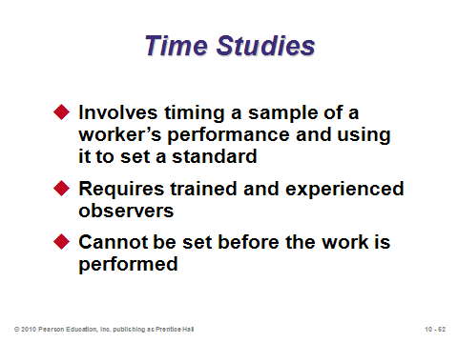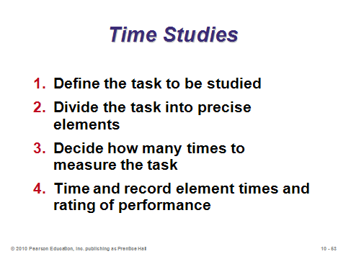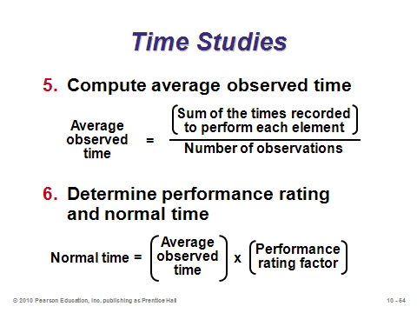

**10-52 10-53 10-54**

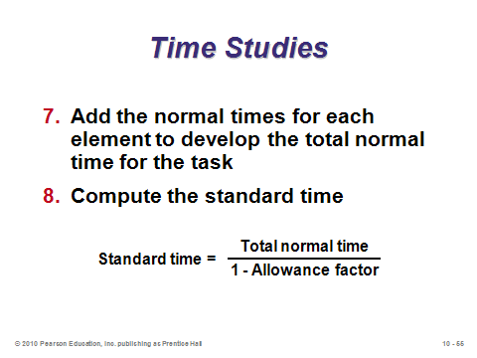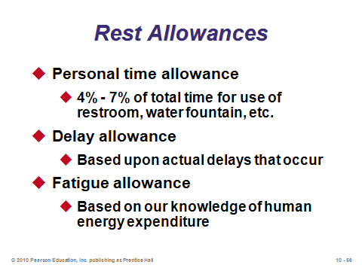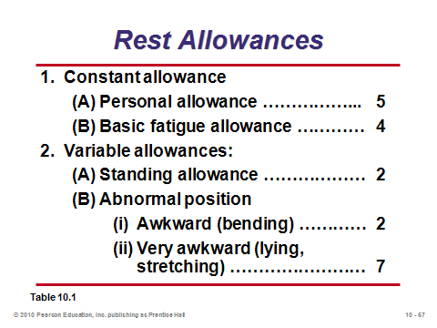

**10-55 10-56 10-57**

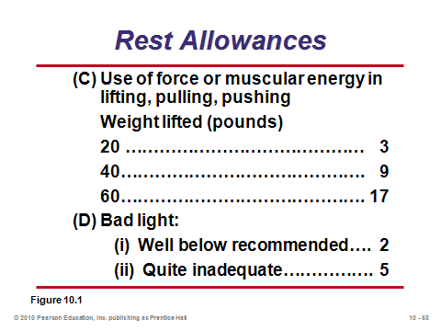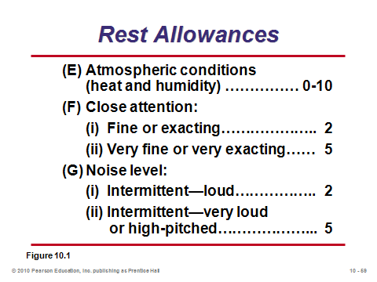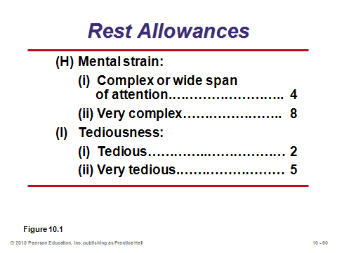

**10-58 10-59 10-60**

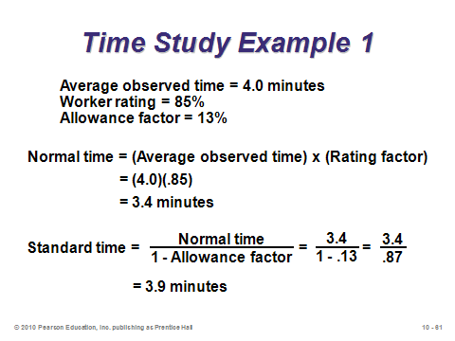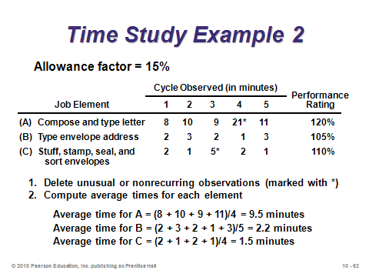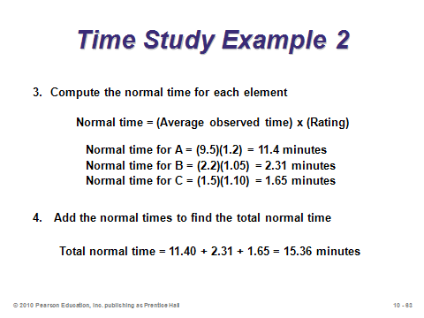

**10-61 10-62 10-63**

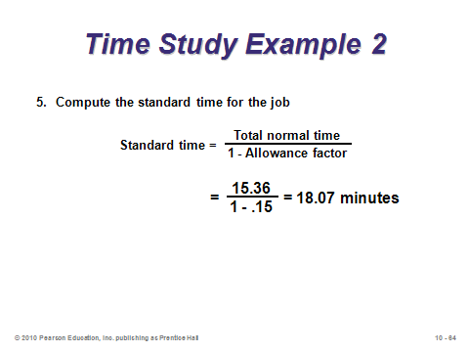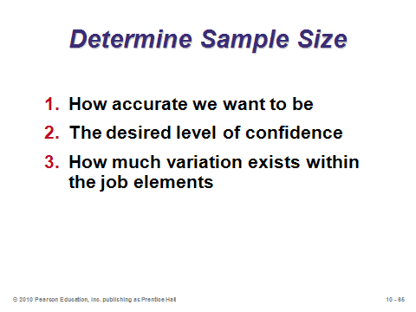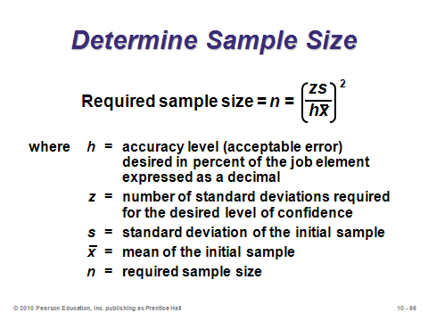

**10-64 10-65 10-66**

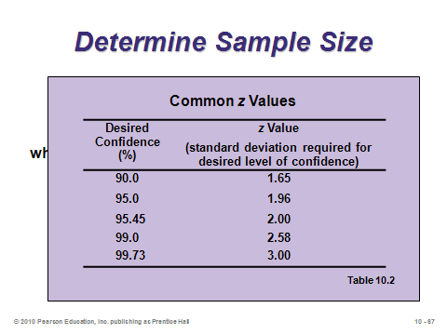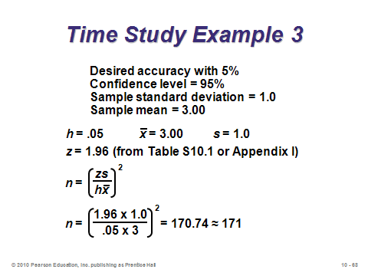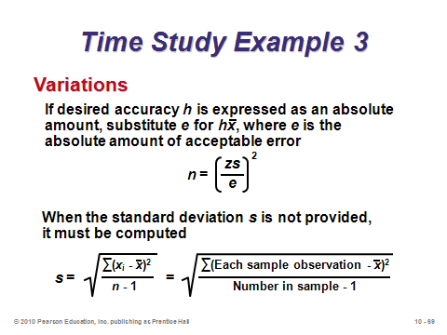

**10-67 10-68 10-69**

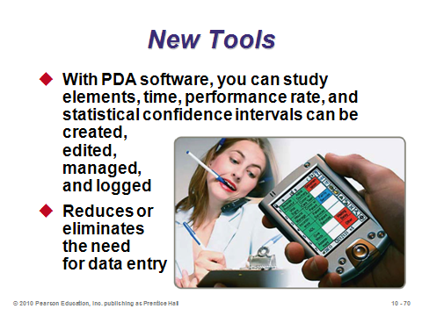

**10-70**

Predetermined Time Standards (10-71 through 10-73)

Slide 71: If work can be broken down into very specific basic motions called *therbligs*, then the analyst can simply sum together well-established times for each therblig to estimate the time for the overall task. This avoids having to run time and motion studies and can be computed before production begins.

Slide 72: The most common predetermined time standard is *methods time measurement* (MTM), a product of the MTM Association. Slide 72 (Figure 10.9) presents a sample MTM table for the “GET and PLACE” motion. The time values are in *time measurement units* (*TMU*s), where 1 TMU = .0006 min. or 100,000 TMUs = 1 hr. Notice how the times differ depending on conditions, such as weight, conditions of GET (easy, difficult, handful), PLACE accuracy (approximate, loose, tight), and the distance range.

Slide 73: This slide presents Example 4 from the text. Times for the first three elements can be retrieved from Slide 72, while times for the other two elements would come from similar tables. After summing together and converting, the total time for this task is 0.14 minutes. Most MTM calculations are actually computerized, so the user need only key in the appropriate MTM codes to determine the overall predetermined time standard.

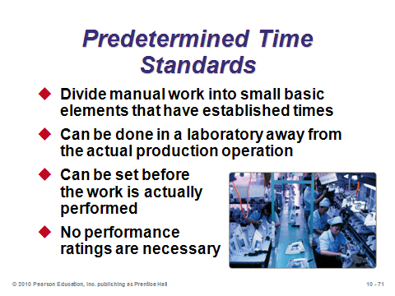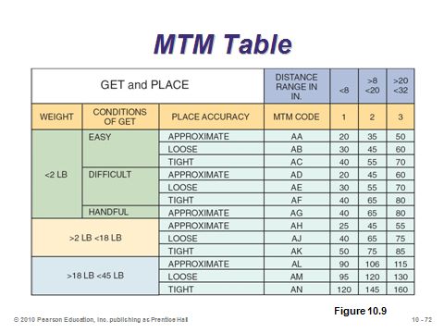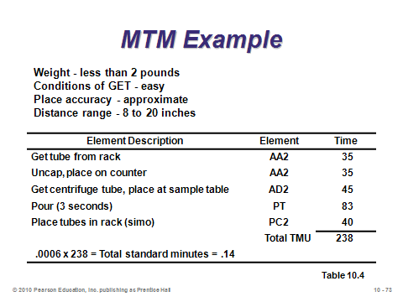

**10-71 10-72 10-73**

Work Sampling (10-74 through 10-82)

Slides 74-82: The final set of labor standards slides covers *work sampling*, which estimates the percent of time that a worker spends on various tasks. The estimates are made via random observations to record the activity that the worker is performing. This method is a more “macro” view of time estimation than the first three methods, which determine very specific task times. Sometimes firms ask employees to self-report how they spent their day, rather than actually observing them (this especially makes sense for white collar office jobs). Slide 75 identifies the five steps of work sampling. The sample size calculation is presented in Slide 76. The formula bears some resemblance to the sample size formula for time studies (Equation (10-4)), but variance ÷ mean2 is replaced with *p*(1 – *p*), where *p* is the estimated sample proportion of the task being measured. Slide 77 presents Example 5 showing a sample size calculation. Slide 78 presents Example 6 showing an application of work sampling. Here management wants employees to be idle 25% of the time. After taking 833 unbiased samples, the study suggests that employees only average 22.6% idle time, so management should consider hiring more employees or otherwise decreasing work burdens. Slides 79 and 80 (Figure 10.10) present results from two work sampling studies. Slides 81 and 82 present the advantages and disadvantages of work sampling, respectively. In short, work sampling is easier and less intrusive than time studies, but it provides more macro and less accurate indications of how workers spend their time.

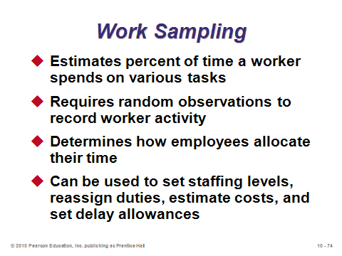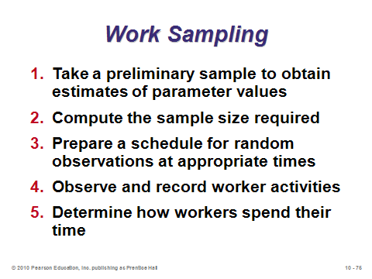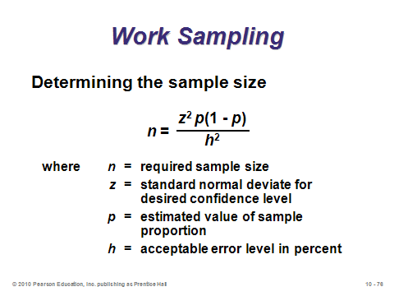

**10-74 10-75 10-76**

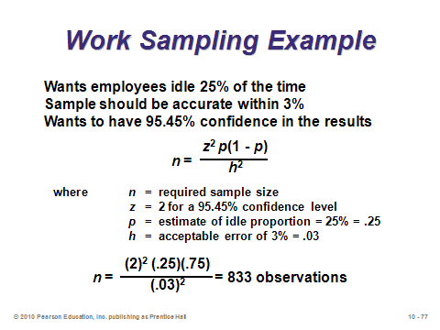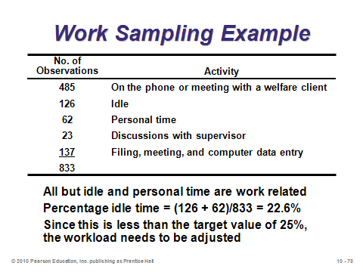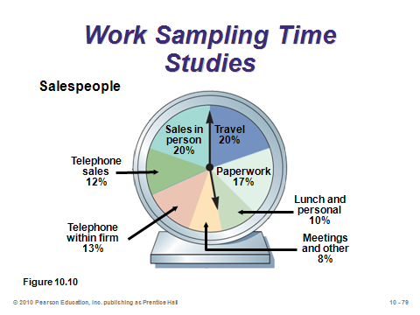

**10-77 10-78 10-79**

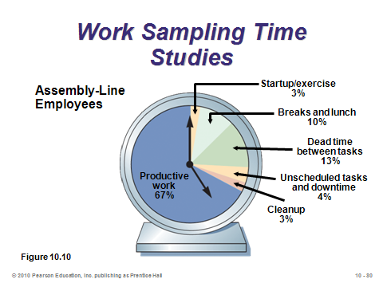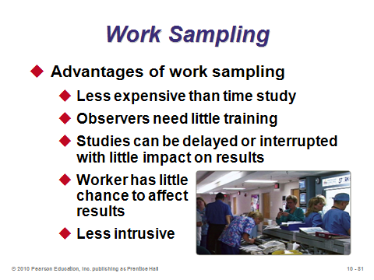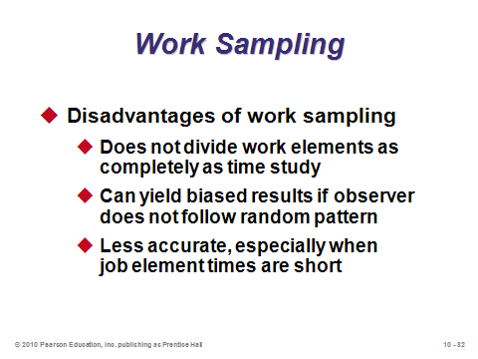

**10-80 10-81 10-82**

ETHICS (10-83)

Slide 83: Particularly because humans are involved, proper job design must take into consideration issues of fairness, equity, and ethics. Operations managers must know the law, as well as generally accepted human resource standards. Most firms have human resource and legal departments to help define appropriate job design parameters. Management must also educate employees about equipment, work rules, and the work environment and enforce the rules even if they are unpopular among employees.

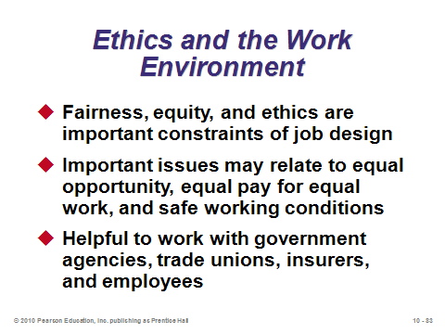

**10-83**

**Additional Assignment Ideas**

1. Have the students perform a work sampling study of their own activities during each day of a regular work week. They need to decide on the basic activity categories (eating, traveling, studying, in class, etc.), compute the number of observations required, and collect and record the data. They should then summarize and report on their analysis.

2. MTM (The Methods Time Measurement Association) has created software for developing labor standards in specialized areas. For example, one area of measurement is Healthcare labor. Find and identify the other four of the specialized areas. (Hint: Start your search at the Web site http://www.mtm.org/. Click on “Systems.”)

**Additional Case Studies**

Internet Case Studies (www.pearsonglobaleditions.com/heizer)

* *Chicago Southern Hospital*: Examines the requirements for a work-sampling plan for nurses.
* *Karstadt versus JCPenney*: Compares the work culture in retailing in the U.S. to Germany.
* *The Fleet That Wanders*: Requires a look at ergonomic issues for truck drivers.

Harvard Case Studies (http://harvardbusinessonline.hbsp.harvard.edu)

* *Southwest Airlines: Using Human Resources for Competitive Advantage* (#HR1A): Considers how Southwest Airlines developed a sustainable competitive advantage via human resources.
* *Eli Lilly: The Evista Project* (#699-016): Explores operational realities of two product development teams.
* *Lincoln Electric* (#376-028): Discusses the compensation system and company culture at this welding equipment manufacturer.
* *PPG: Developing a Self-Directed Workforce* (#693-020): Considers the process of creating a self-directed workforce, including the theory and difficulties.

Richard Ivey School of Business (http://cases.ivey.uwo.ca/cases/pages/home.aspx)

* *Thera-aid Medical Devices* (#9A96D007): Teams of students can be asked to develop an assembly process for the new product using either an assembly line or single operator configuration. Students must use job design and work measurement methods to estimate overall product cost and propose alternative prototype designs that might reduce assembly costs. Subsequent discussion can focus on the challenges of work design for an assembly line or single operation configuration, along with the quality, cost, and management challenges implicit in each.

**Internet Resources**

|  |  |
| --- | --- |
| Applied Computer Services, Inc. | www.acsco.com |
| Bibliography on teams and teamwork | www.hq.nasa.gov/office/hqlibrary/ppm/ppm5.htm |
| Ergonomics at the University of Toronto | vered.rose.toronto.edu |
| H.B. Maynard and Company, Inc. | hbmaynard.com |
| Human Measurements by Open Ergonomics Ltd. | www.openerg.com |
| Human modeling by UGS | www.ugs.com/products/efactory |
| Institute of Industrial Engineers | www.iienet.org |
| Methods Time Measurement Association | www.mtm.org |
| Occupational Safety and Health Administration | www.osha.gov |
| Quetech Ltd. | www.quetech.com |
| Tectime Data Systems Ltd. | www.tectime.com |
| Visual training systems by Quality Methods Intl. | www.visual-workplace.com |
| World at Work | www.worldatwork.org |

**Other Supplementary Material**

Videos

*Cheaper by the Dozen* *(Clifton Webb and Myrna Loy), 20th Century Fox, 1950*

This is the story of the Gilbreth family.

Films available from:

Society of Manufacturing Engineers

One SME Drive P.O. Box 930

Dearborn, Michigan 48121-0930

(P) 313-425-3000

(F) 313-425-3412

http://www.sme.org

* *Managing Teams in Manufacturing*—Practical management agenda to help you focus on avoiding pervasive pitfalls that often limit team performance. Order # PI-VT506-3456
* *Ergonomics in Manufacturing*—See how ergonomics can effectively boost manufacturing productivity through increased worker productivity, lower absenteeism, and dramatically reduced health claims. Order # PI-VT507-3456
* *Ergonomic Safety*—Four steps to setting up an effective ergonomic safety program, a ten point ergonomic approach to reviewing the workplace environment, and what the future holds for ergonomic safety. Order # PT-VT618-3456
* *Work Measurement—*Shows how manufacturers are using the process to measure productivity improvements. Order # PI-VT641-3456

Commercial Software

* A.D.A.M. Interactive Physiology

A.D.A.M.

1600 River Edge Parkway, Suite 100

Atlanta, Georgia 30328

(P): 770-980-0888

Web site: <http://www.adam.com>

* Jack software simulates humans performing various tasks in different environments.

UGS Tecnomatix (part of Siemens)

5800 Granite Parkway, Suite 600

Plano, TX 75024 USA

(P) 1 972 987 3000

http://www.ugs.com/products/tecnomatix/human_performance/jack/movies.shtml

* 4M System, Computerized Work Measurement Technology

MTM Association for Standards and Research

1111East Touhy Avenue

Des Plaines, Illinois 60018

(P): 847-299-1111

(F): 847-2999-3509

Web site: http://www.mtm.org